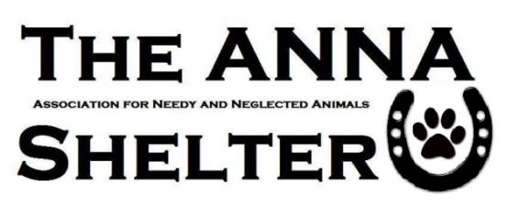
SMALL ANIMAL ADOPTION APPLICATION
TODAY’S DATE:

WHAT ANIMAL ARE YOU APPLYING FOR:

Welcome to the ANNA Shelter. We are glad you have come to adopt a new pet from our shelter. In order to be considered as an adopter today, you must: • Be 21 years of age or older; • Have identification showing your present address; • Have the consent of your landlord (if applicable); • Be able and willing to spend the time, money and provide the necessary training, medical treatment, and proper care for a pet. The adoption of a lifelong animal friend should not be impulsive, but a carefully thought out decision, which will ensure a loving, lasting, FOREVER relationship.
Basic Information
NAME: __________________________________________________________________________
STREET ADDRESS:_______________________________________________________________
CITY: _____________________________________ STATE: ___________ ZIP: ________________
HOME PHONE: _____________________WORK/CELL PHONE:____________________________ EMAIL:__________________________________________________________________________
BIRTHDATE:: _________________ Are you a student: ⇰Yes ⇱No
Housing Information
Do you own your home? ⇰Yes ⇯No (Home Ownership will be verified) How Long? __________________
Type of home: ⇸Single Family ⇯ Trailer ⇯Apt./Townhome/Condo ⇯Other_____________________
If you rent, please provide your landlord’s contact information below (Your landlord will be contacted.)
Name/ Phone Number:_____________________________________________________________
Does your lease require a pet deposit: ⇸Yes ⇯No
If yes, have you paid that deposit (proof may be necessary) ⇮Yes ⇮ No
Household information:
# of adults _________ Do all adults know that you plan to adopt a pet?  Yes ⇬No
#Children _____ Children’s ages: ____________________________________________________
Is the primary applicant employed?
 Yes  Name of Employer ___________________________Length of Employment:________
⇬No Explain the primary source of income: ____________________________________________

By signing below, you are confirming the information on this application is accurate and true. Failure to disclose information, providing false or inaccurate information will slow down and possibly halt an adoption. We want the best possible match for our animals. Animals require basic needs and some require special needs and circumstances and we take that VERY seriously.

- We reserve the right to deny an application for ANY or NO reason.

- Completing an application does NOT guarantee adoption.

Signature: ______________________________________________Date:___________________________

